Centripetal Force

Equipment

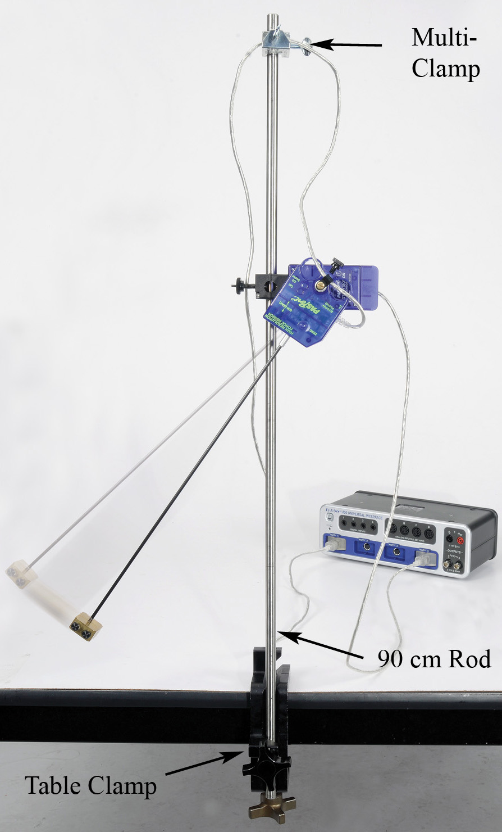

|  |  |  |
| --- | --- | --- |
| Qty | Items | Part Number |
| 1 | Rotary Motion Sensor | PS-2120 |
| 1 | High Res Force Sensor | PS-2189 |
| 1 | Centripetal Force Pendulum | ME-9821 |
| 1 | Table Clamp | ME-9472 |
| 1 | 90 cm Rod | ME-8738 |
| 1 | Multi-Clamp | ME-9507 |
| 1 | Braided String | SE-8050 |
| Required but not included: | | |
| 1 | Meter Stick | SE-8695 |
| 1 | Balance Scale | SE-8723 |

Introduction

For an object moving in a circle, the Centripetal Force is the name given to the sum of the components of all the forces acting on the object directed toward the center of the circle.

In this experiment, the Centripetal Force is directly measured using a Force Sensor. The dependence of Centripetal Force on radius and angular velocity is investigated.

The Force Sensor, supporting the pendulum, mounts directly onto the shaft of the Rotary Motion Sensor. As the pendulum oscillates back and forth, both force and angular velocity are recorded.

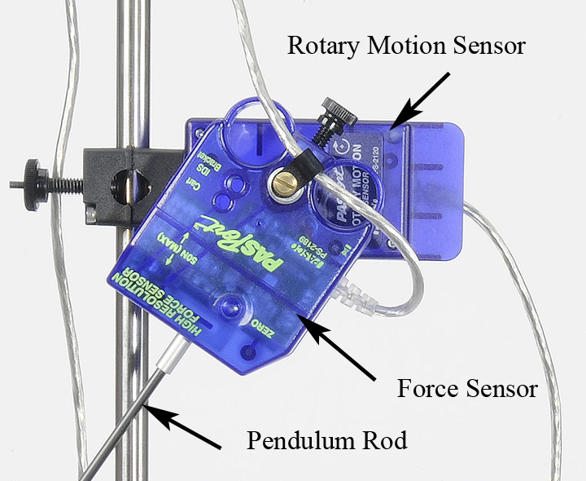

Figure 1: Setup

Setup

1. Use the Table Clamp and 90 cm rod to support the Rotary Motion Sensor as shown in Figure 1. Plug the Rotary Motion Sensor into the interface.

Figure 2: Force Sensor on Rotary Motion Sensor

1. Use the thumb screw and clip (see Figure 3) to fasten the Force Sensor cable at the center of rotation. This greatly reduces the effect of the cord on the motion of the pendulum.

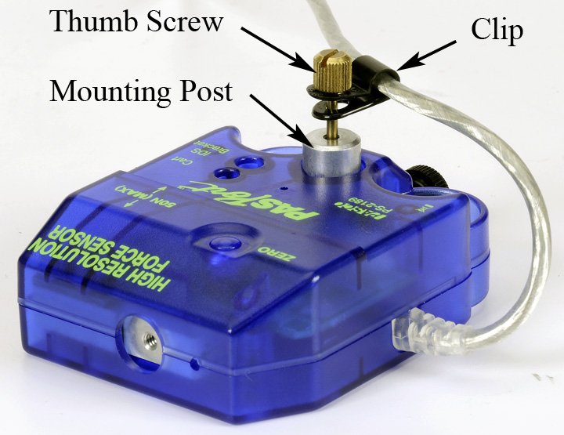

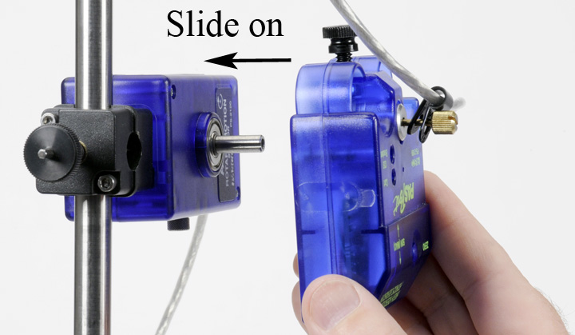

Figure 3: Cord through Clip Figure 4: Attach Force Sensor to Rotary Motion Sensor

1. Slide the Force Sensor with mounting post onto the Rotary Motion Sensor shaft as shown in Figure 4, and tighten the brass thumbscrew. The black plastic thumbscrew fastens the Force Sensor to the mounting post.
2. Use the multi-clamp to support the Force Sensor cable directly above as shown in Figure 1. Plug the Force Sensor into the interface.
3. Use the two thumb screws to attach the two-piece brass pendulum mass to the rod as shown in Figure 5. Later in the experiment, the mass will be located at various radii, but for now place the bottom of the mass flush with the end of the rod.
4. Screw the pendulum rod into the Force Sensor as shown in Figure 2.

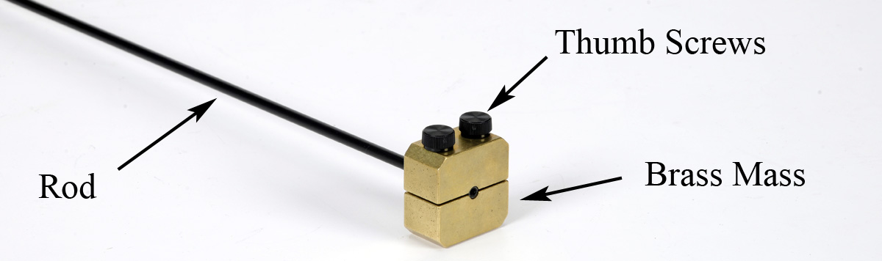

Figure 5: Attaching the Brass Mass

1. In PASCO Capstone, set the Common sample rate to 100 Hz.
2. Create a graph of Angular Velocity vs. Time. Add a plot area and put the Force on the vertical axis.

Procedure for Constant Radius

1. With the pendulum stationary, tare the Force Sensor using the zero button on the case. This will tare out the weight of the pendulum, so that during the experiment, the Force Sensor will be measuring only the force due to the pendulum's rotation.
2. Displace the pendulum from equilibrium (as shown in Figure 1), click on Record and release the pendulum. Immediately click on Stop: You want to record only 1/2 of a cycle.
3. Check the sign of the angular velocity data as it was released from rest. It needs to be **positive**. Open the Data Summary and click on the properties icon (gear) for the Rotary Motion Sensor. Note the check box to change the sign. You should also click on the "Zero Now" button: This will make the angle zero when the pendulum is at rest. You can also zero the Rotary Motion Sensor on the Experiment Control Bar at the bottom of the page.
4. Check the sign of the **force** data. It also needs to be **positive**. If necessary, open the Data Summary and click on the properties icon for the Force Sensor and change the sign. Once you are sure that everything is correct, delete all data runs.

In the next part, you will let the pendulum oscillate continuously while you take several short data sets. Each data set only needs to be about one or two cycles long. You want to see at least one maximum in the angular velocity data: This corresponds to when the pendulum is at the bottom of its swing.

1. 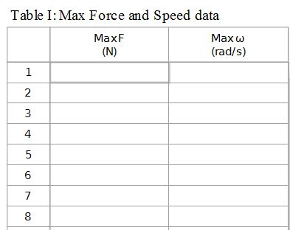Displace the pendulum from equilibrium, turning it nearly upside down. Release the pendulum: After it has oscillated one cycle, click on record and take data for one or two cycles, and then click on stop. Without touching the pendulum, record data for another couple of cycles. The only important part of each data run is that you see a maximum value for the angular velocity data. Keep recording more cycles (without disturbing the pendulum) until the angular velocity maximum is below 1 rad/s. You should get at least 10 runs.

Force and Speed Data

1. Create a table as shown: Create User-entered data sets called “Max F” with units of N and “Max ω” with units of (rad/s).
2. Using the data selector in the graph tool bar, select run #1. Turn on the statistics with the maximum selected.
3. Make sure that the two maxima are for the same time. Turn on the Multi-coordinates tool.
4. If the data seems too noisy, try using the smoothing tool.
5. Enter the values for the maximum force and speed in Table I. Repeat for your other runs.

F vs. Speed

1. Create a graph of Max F vs. Max ω. In general, the Centripetal Force is the sum of the components of **all** the forces acting on the pendulum mass directed toward the center of the circle, which should include the weight of the pendulum. But for this data, the force data **is** the centripetal force. Why?
2. Is your data linear? Is the centripetal force directly proportional to the angular velocity?
3. Use a QuickCalc and change the horizontal axis to ω². Is the data linear now? How does the centripetal force depend on the angular velocity?
4. Use a linear fit and record the slope for later use. What are the units?

Vary Radius

1. In this section, you will vary the radius. Slide the brass mass up the rod, and use a meter stick (see Fig. 6) to position the **top** of the mass 20 cm from the center of rotation.
2. 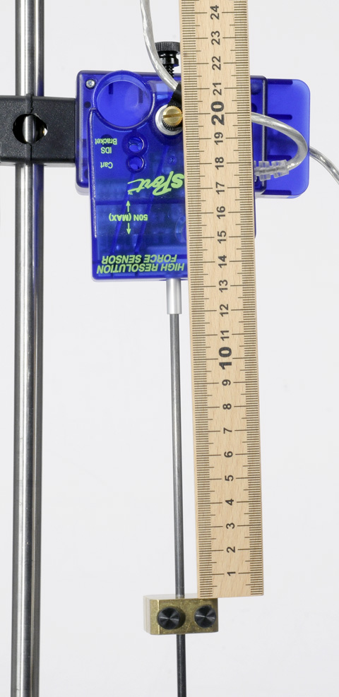Add a digits display and put the angle on it. For each run, you want the initial amplitude of the angular velocity to be about 4 rad/s. This is determined by the initial angular displacement, and thus it helps to watch the angle.
3. With the pendulum at rest, click on Record. Displace the pendulum about 30° and release. If the initial max angular velocity is not about 4 rad/s, then stop recording and try another run, adjusting your initial displacement accordingly.
4. You want to record data until the angular velocity amplitude is below 3 rad/s.
5. In this section, you will vary the radius, but the force will always be read when the angular velocity is about 3 rad/s.
6. Since there is a lot of uncertainty in this measurement, you will take several measurements at each radius.

Figure 6: Radius

1. Create Table II as shown: Create a User-Entered data set called “Force1” with units of N. Turn on the Mean and Standard Deviation statistics.
2. Create Table III as shown: Create User-Entered data sets called “Radius” with units of cm and “Avg F” with units of N.

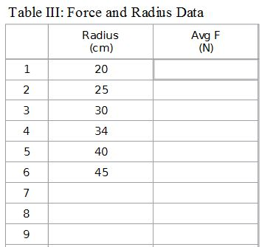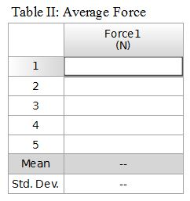

1. Examine the data carefully. You want to find the time when the amplitude angular velocity is as close as possible to 3 rad/s (in either direction). At that time, measure the maximum **positive** force.
2. Once you have a good run, use the Multi-coordinates tool to measure the force (Force1) at 3 rad/s. and enter your values in Table II. When you get a good solid average, enter that average force in Table III. Repeat for all radii listed in Table III.
3. Create a graph of Avg F vs. Radius. Is your data linear?
4. How does the centripetal force depend on the radius?

Analysis

In this experiment, you found that the centripetal force on an object travelling in circular motion is directly proportional to the radius (r) of the circle, and proportional to the square of the angular velocity (ω). This can be summarized as

Fc = mr ω²

where m is the mass of the object in circular motion. Thus a graph of F vs ω² results in a straight line with a slope equal to "mr".

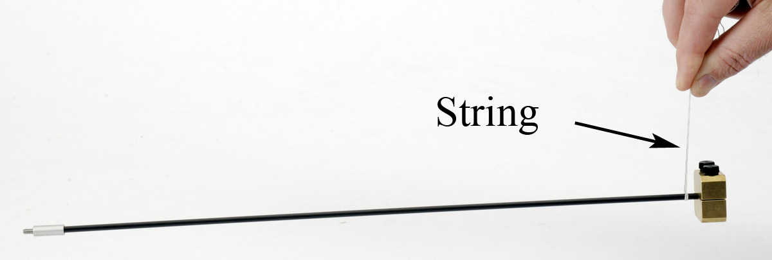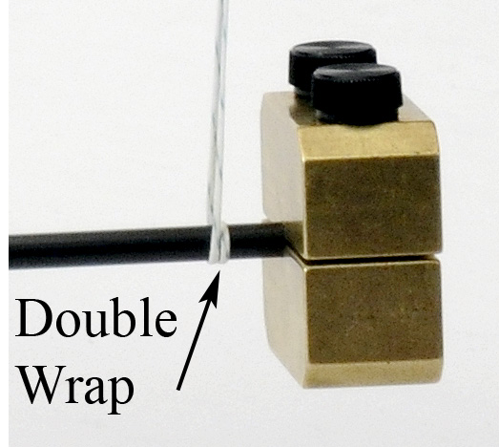

Figure 7: Finding the Center of Mass of the Pendulum

1. Reposition the brass mass back flush with the end of rod, as it was in the first part of the experiment. Measure the distance from the **top** of the mass to the center of rotation. Why is this not the correct radius to use in the equation?
2. Remove the pendulum and rod from the Force Sensor and use a Balance Scale to find its mass.
3. Use this mass and the slope from graph #1 to find the effective radius (r).
4. How does your calculated effective radius compare to the length you measured in part 1, above?
5. Use a piece of string (see Fig. 7) to balance the pendulum and find the center of mass.
6. Determine the distance from the center of mass of the pendulum to the center of rotation. How does your calculated effective radius compare to this value?